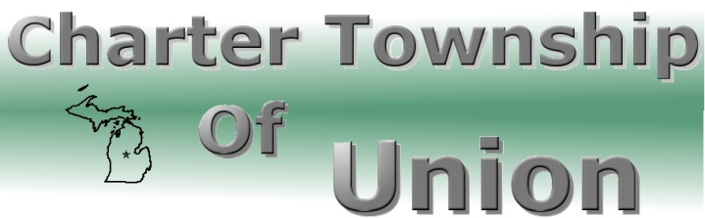

BOARD OF TRUSTEES
Regular Meeting
September 12, 2012
7:00 p.m.

- CALL MEETING TO ORDER

- PLEDGE OF ALLEGIANCE

- ROLL CALL

- PUBLIC COMMENT: Restricted to three minutes regarding issues on this agenda

- REPORTS/BOARD COMMENTS

- APPROVAL OF AGENDA

- CONSENT AGENDA
- Communications
- Minutes – August 14, 2012 Special Meeting
August 22, 2012 Regular Meeting
- Bills
- Payroll

- BOARD AGENDA
- Land Division – Saginaw Chippewa Indian Tribe, Parcel #14-012-40-002-04,
14-012-30-001-00, 14-012-40-002-03 and 14-012-40-007-08
- Land Division- Twenty-West – Parcel 14-017-40-009-03
- 2012 Millage Levy Request

9. EXTENDED PUBLIC COMMENT

10. FINAL BOARD MEMBER COMMENT

11. ADJOURNMENT

